BizTalk Server 2004
Business Activity Monitoring for
HL7 Processing

Design considerations for building Business Activity Monitoring capabilities into HL7 data integrations

Prepared for Microsoft Corporation by Entropy Solutions, a division of Partner2Learn, Inc.
Copyright

The information contained in this document represents the current view of Microsoft Corporation on the issues discussed as of the date of publication. Because Microsoft must respond to changing market conditions, it should not be interpreted to be a commitment on the part of Microsoft, and Microsoft cannot guarantee the accuracy of any information presented after the date of publication.

This White Paper is for informational purposes only. MICROSOFT MAKES NO WARRANTIES, EXPRESS OR IMPLIED, AS TO THE INFORMATION IN THIS DOCUMENT.

Complying with all applicable copyright laws is the responsibility of the user. Without limiting the rights under copyright, no part of this document may be reproduced, stored in or introduced into a retrieval system, or transmitted in any form or by any means (electronic, mechanical, photocopying, recording, or otherwise), or for any purpose, without the express written permission of Microsoft Corporation.

Microsoft may have patents, patent applications, trademarks, copyrights, or other intellectual property rights covering subject matter in this document. Except as expressly provided in any written license agreement from Microsoft, the furnishing of this document does not give you any license to these patents, trademarks, copyrights, or other intellectual property.

© 2004 Microsoft Corporation. All rights reserved.
Table of Contents
Background 5
What is Business Activity Monitoring? 5
Using Business Activity Monitoring with HL7 Processing to Improve Hospital Processes 5
Configuring BizTalk Server 2004 for Business Activity Monitoring 6
Building a Business Activity 7
Building a Business Activity Monitoring View 9
Deployment Options 16
Deploying the BAM Definition 17
Using the BAM Deployment Tool 17
Populating the BAM View and Tracking BAM Activities 19
Integration Using the BAM SDK 19
Integration at the Orchestration Layer 20
Designing Your HL7 Processing to Implement a BAM Solution 20
Building a Basic HL7 Processing Solution 20
Deploying the Necessary HL7 Schema 20
Deploying the Project Containing MSH and ACK Schemas 22
Deploying the Version-Specific Definitional Schemas 23
Deploying Specific Message Schemas 23
Configuring Acknowledgments 25
HL7 Receive Pipeline 26
HL7 Send Pipeline 27
Mapping HL7 Data 28
Configuring an Orchestration to Accept an HL7 Message 29
Sample Orchestrations 32
Integration with BizTalk Server 2004 Using the Tracking Profile Editor 34
Creating a New Tracking Profile 34
Aggregating Events with Continuation Tokens 37
Deploying the Tracking Profile 39
Viewing BAM Activities 40
Charts and Graphs 40
Summary 41

Background

A recent study conducted by Gartner Group asked hospital executives the following question: “What keeps you up at night?” The top two issues most often cited by this group were 1) Medicare/Medicaid reimbursement and 2) staffing issues.

Healthcare executives today are looking to alleviate these pains through the implementation of quality systems such as Six Sigma. These programs aim to optimize hospital processes, thereby reducing the number of billing errors and effectively managing human capital. However, without a solid foundation of facts, such initiatives will have a difficult time solving these challenges.

This white paper discusses how the Microsoft® BizTalk® Server 2004 platform is a cornerstone for enabling this “foundation of facts” necessary for today’s dynamic hospital environment. This is accomplished through use of BizTalk Server 2004, Microsoft BizTalk Accelerator for HL7, and the Business Activity Monitoring (BAM) capabilities of BizTalk Server.

What is Business Activity Monitoring?

Business Activity Monitoring (BAM) is about intercepting, aggregating, and analyzing technical events along with business data in real time to provide a business-oriented view into your processes.

At the heart of BAM is the concept of a business activity. Unlike technically oriented events, such as raising an error condition or the appearance of a message in a queue, a business activity is the intersection of data, business and process logic, and context. With a business process integration platform like Microsoft BizTalk Server 2004 in place, we can handle and recognize technical events regardless of whether they occur in one application or many. Using orchestration, we can aggregate these technical events along with the corresponding data to build the foundation that will allow the definition of business activities.

BAM makes it possible for developers, business analysts, and end users, working individually or collaboratively, to extract the data they need from their business processes. The business analyst produces a Microsoft Excel workbook that defines what the important data is and how it should be interpreted. Temporary data is generated to implement the calculations in the workbook, interpret the data (key performance indicators, or KPIs), and create related charts and trends.

Using Business Activity Monitoring with HL7 Processing to Improve Hospital Processes

Hospitals have many criteria that must be satisfied in order to be reimbursed by Medicare/Medicaid for technical services they provide. These services might include lab tests, facility charges, and x-rays, among many other things. The hospital must demonstrate not only that these services were performed because they were needed, but also that they were provided in a timely manner. To aid in measuring the timeliness and efficiency of treatment, the Centers for Medicare and Medicaid Services (CMS) established the diagnosis-related group prospective payment system (PPS). The payments that hospitals receive for Medicare Part A claims under the PPS depend on a number of factors such as if the hospital is in a rural or urban area, if it is a teaching hospital, or if it treats an inordinate amount of a particular diagnosis.

While these factors are important, they are not indicators of a hospital’s process quality and efficiency. This is where the length-of-stay criteria become a key part of the formula. Part of the payment calculation includes length-of-stay (LOS) criteria for over one thousand different diagnoses, called diagnosis-related groups (DRGs). For example, a spinal fusion needed to fix a back problem (DRG #497) usually takes about five days (LOS).

Using this standard, Medicare has mandated that hospitals will only be reimbursed for the LOS outlined by CMS for a particular DRG. So in our previous example, if the patient with back problems stayed in the hospital for six days, the hospital would most likely not be reimbursed for the cost of the sixth day. As a result, hospital administrators want to know when procedures they are performing are taking longer than expected. This scenario hits both of the top two concerns for executives, because if you are missing LOS targets for DRGs, then you will not get reimbursed and you probably have a process issue with how your staff interacts.

What is needed is a way for these administrators to measure LOS by DRG on both an individual case level and an aggregate level for the facility. In addition, with the real-time capabilities of BizTalk Server, information can be automatically transmitted to nurses and physicians about patients who are about to exceed the Medicare requirements for LOS for their DRG before it’s too late.

Hospital administrators also have a much more valuable indicator of overall resource effectiveness than a generic length-of-stay metric as a result of this solution. By measuring against a specific diagnosis, a much more accurate picture of overall performance can be attained.

Cases that exceed LOS requirements can be useful starting points for process-improvement initiatives. By using Business Activity Monitoring, these cases can be drilled down to expose details such as the following:

- How long did the physician have to wait for radiology to produce needed x-rays?
- How often are patients asked to wait more than 15 minutes to be triaged?
- What areas of the hospital are experiencing the most volume?
- Can staff or beds be reallocated to more effectively manage patient flow?

Configuring BizTalk Server 2004 for Business Activity Monitoring

Having identified the need and fit for a BAM solution combined with HL7 data processing, the first step is to determine what data, facts, and context need to be represented in the BAM dashboard.

To properly define these criteria, the BAM installation includes a spreadsheet that contains several macros that provide the links to the BAM server. In a default installation this spreadsheet is called BAM.xls and is located in C:\Program Files\Microsoft BizTalk Server 2004\Tracking.

Typically, a knowledge worker will make a copy of this spreadsheet, and build a “wish list” of data and facts that he would like to build a report on. He will do this by walking through a wizard-driven interface in the spreadsheet. The next few sections will walk you through how to define the data and facts to be included in the BAM dashboard. At a high level, the knowledge worker will define the key activities to be monitored at an abstract level, and then define how he would like the information structured into a view.

The nice thing about this approach is that business users can define their needs using a familiar user experience (Excel) and the result is at an abstract level, so the knowledge worker does not need to know how or where that data is coming from.

Design Tip
While a file can hold multiple activities, only one view can be stored in each spreadsheet, so name spreadsheet files after a view.

Building a Business Activity

The first step is to define the business activities that form the foundation for our view. A business activity is a collection of related data, facts, and context all rolled into one.

To define a business activity, copy C:\Program Files\Microsoft BizTalk Server 2004\Tracking\BAM.xls into a separate folder and rename it. In the scenario discussed here, it is named COO_View.xls. You will notice a new menu item called BAM at the top of the spreadsheet window. One of the menu items under BAM is BAM Activity. Select BAM Activity as shown in Figure 1.
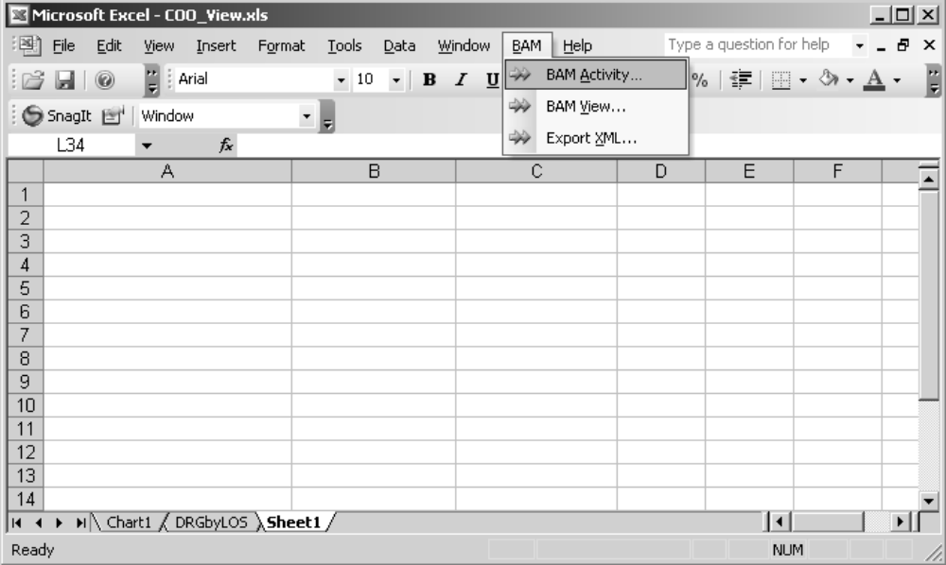
Figure 1 - Select BAM Activity from the menu

By selecting this, you will be taken to the first step in the BAM Activity Wizard. Select New Activity and you will see a screen similar to Figure 2. Type the name of your activity. In this scenario, the activity is called PatientFlow. It will define the data and context associated with the length of time a patient is admitted to our facility versus the allowed time for that patient’s DRG code.

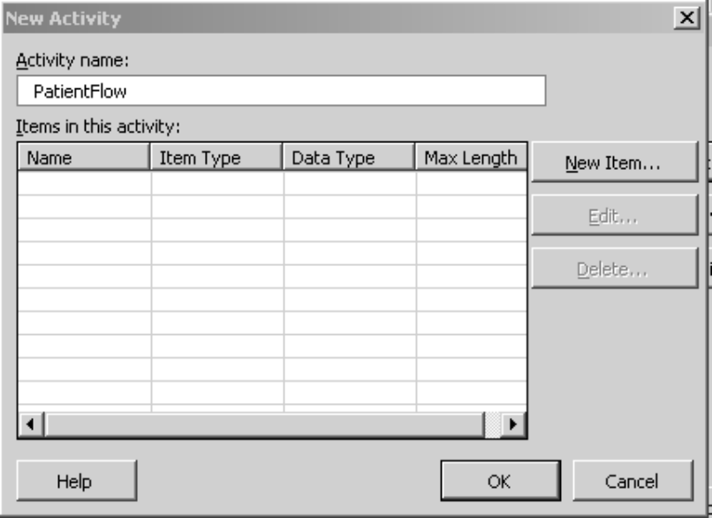
Figure 2 - Creating a new business activity

Next, a set of related data needs to be built around the activity. To do this, click the New Item button. Give the item a name and then you can select one of several item types:

- Business Milestones: Used to define a time context associated with the activity, such as the beginning or ending time of an event.
- Business Data – Text: Assigned to text elements that should be displayed in the view.
- Business Data – Integer: Assigned to calculated and/or displayed integer elements that should be displayed in the view.
- Business Data – Float: Same as integer elements but used with float data types.

Keep in mind that items are not limited to only the data that appears on a single message or even any message at all. At this point, all that’s being done is defining what data and context needs to be part of the view. Computations such as average, min, or max can all be done within the BAM infrastructure, and BAM can also correlate multiple messages, processes, and data sources (using BizTalk), so do not feel like your view is limited to the data that exists in a particular message.

For our scenario, complete the following steps:

- Click New Item to open the BAM Activity Item dialog box.
- Type Admit for Item Name.
- In the Item Type box, select Business Milestones.
- Click OK to save the item.
- Repeat the previous steps to add the following items. For the Business Data items, make the associated choices.
Item Name | Item Type | Length
Admit | Business Milestones
Discharge | Business Milestones
DRG Description | Business Data - Text | 50
DRG Code | Business Data - Text | 50
Order_InProcess | Business Milestones
TargetLOS | Business Data - Float | 50
When complete, your PatientFlow activity should look like Figure 3 below:
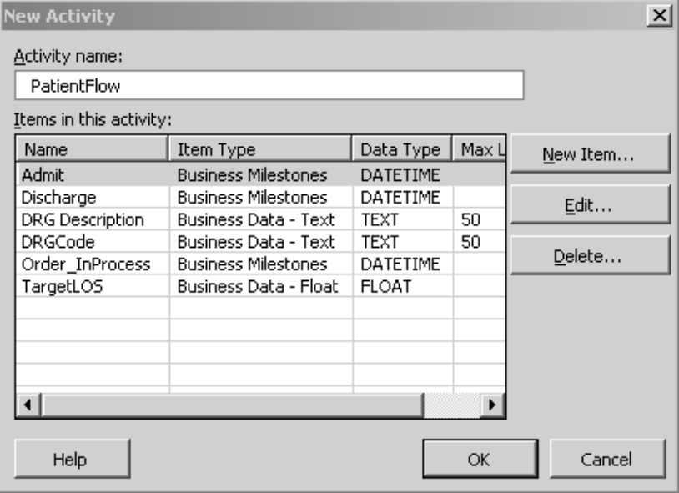
Figure 3 – Item definition for the PatientFlow activity

Once you have completed entering all of the aspects of the activity, click the OK button. If you have other activities that make up the view you anticipate building, you can define them. Otherwise, click the OK button again to complete building business activities and to launch the Business Activity Monitoring View Wizard.

Building a Business Activity Monitoring View

Once you have defined the business activity(ies) you want to monitor, you need to define how you want information about the activity presented. To build a BAM view, you may either select BAM View from the BAM menu, or, if you just created a BAM activity, you will automatically be taken to the BAM View Wizard.

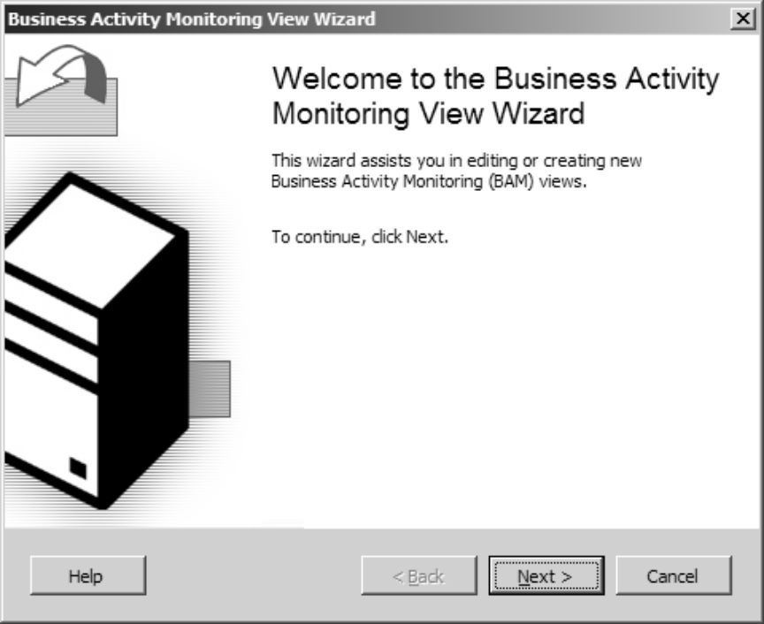
Figure 4 - The BAM View Wizard

Click Next, and you are taken to a screen where you can create, edit, or delete views that are associated with the current workbook.

Design Tip
If you need to delete a view that you have already deployed to the server, make sure to delete the view from the server as well by using the bm.exe tool (covered later).

Click Next again to create a new view and give it a logical name. Select the activities to be included in the view and click Next. For our scenario, name the view DRGbyLOS and select the Select all activities check box to select the PatientFlow activity.

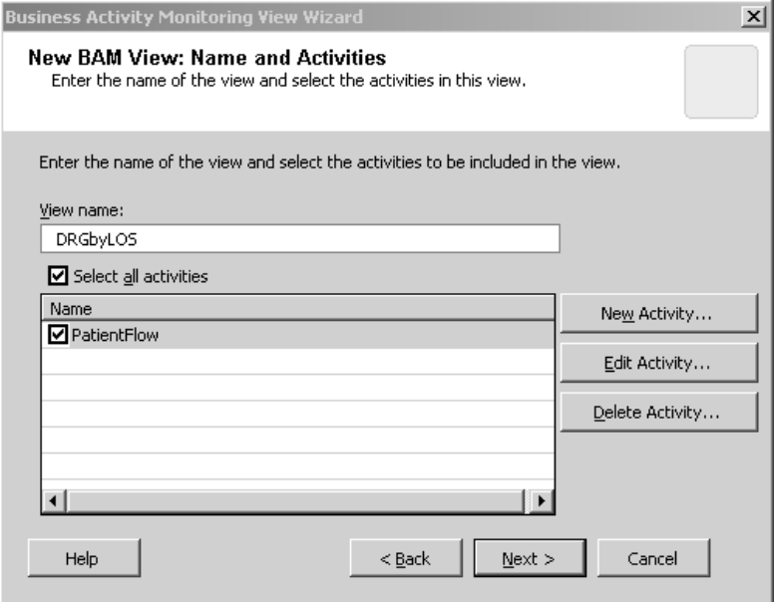
Figure 5 - Select the activities to be included in the BAM view

The next step in the wizard will prompt you to select the items from the activities you chose previously. Depending on how you have structured your view(s) you may or may not want to have all items included.

For our scenario, select all items in this view by selecting the Select all items check box.
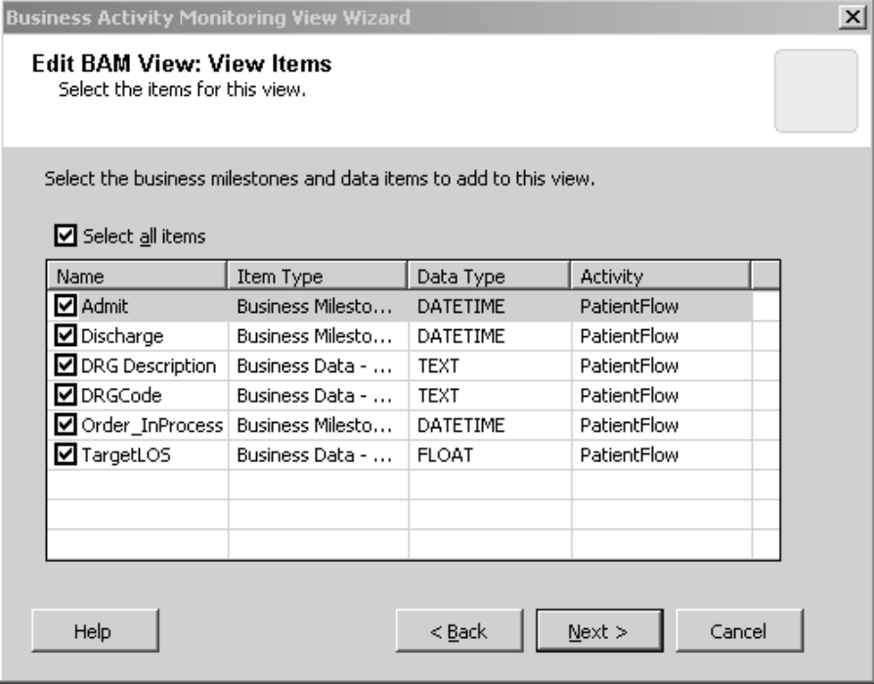
Figure 6 - Select the items to include in the view

The next step is a key step in building your view. This is where you build facts and context from the individual data points. Here, you will build relationships between, for example, the admit time and the discharge time to define the length of stay.

For our scenario, at the next wizard screen as shown in Figure 7 below, we are going to create three new Durations:

- actualLOS – Defined as the time between admission and discharge
- recoverytime – Defined as the time between an ordered procedure and discharge
- TriageWait – Defined as the time between admission and the first ordered procedure
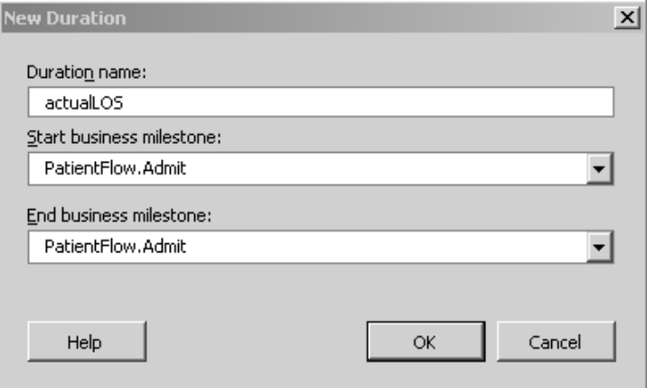
Figure 7 - Sample Duration configuration

To do this, complete the following steps:
- Click the New Duration button.
- In the Duration Name box, type actualLOS.
- Select PatientFlow.admit as the Start business milestone.
- Select PatientFlow.discharge as the End business milestone, and then click OK.
- Repeat the previous steps to add the following durations:
Duration Name | Start Business Milestone | End Business Milestone
recoverytime | PatientFlow.Order_InProcess | PatientFlow.discharge
TriageWait | PatientFlow.admit | PatientFlow.Order_InProcess

- Click Next.

The next screen displayed in the BAM View Wizard is the aggregation dimensions and measures, shown in Figure 8. Aggregating information is a key to building the dashboard layer of the BAM framework. Here we can take large amounts of complex data and start to make it more easily managed from a high level to get an overall view of the business.

We have two options at this step.
- New Dimension
  - Progress: Used to describe the life cycle of a business process, such as what stage a patient is in during an encounter (triage, awaiting surgery, discharge, etc).
  - Data: Allows the view to be built around a particular data element, such as a listing by DRG code.
  - Numeric Range Dimension: Defines ranges to be assigned typically for low/medium/high groupings. An example would be claims below $1000 are grouped as low, $1000 and above are high.
  - Time Dimension: Used to display information by a base business milestone.

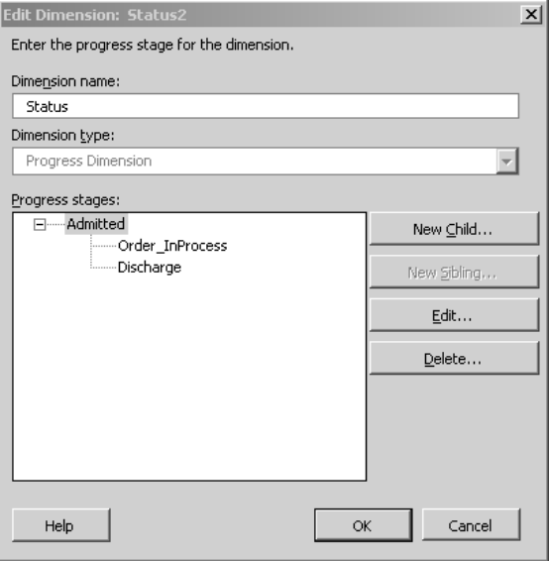
Figure 8 - Aggregation Dimension

- New Measure: Allows you to perform aggregate functions on items and sets of related items (such as a duration). For example, a measure allows you to calculate the average length of stay across all patient encounters, or a subset of encounters, such as diagnosis code.

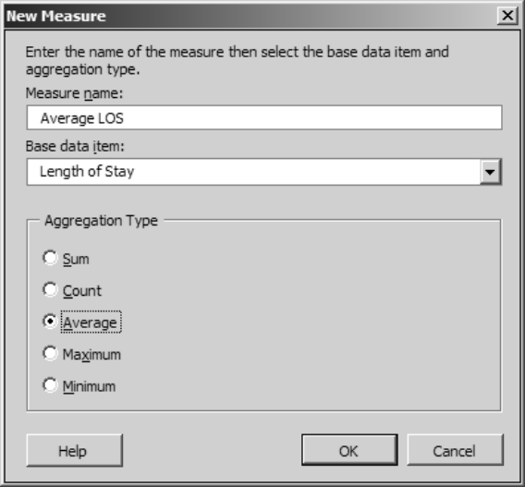
Figure 9 - Defining a new measure for average length of stay

For our scenario, complete the following steps to add measures and dimensions to the view:

Create one data dimension. | - In the New BAM View – Aggregation Dimension and Measures dialog box, click the New Dimension button.  - In the Dimension Name box, type DRG.  - In the Dimension Type box, select Data Dimension.  - From the list of Available data items that appears, select PatientFlow.DRG Description, and then click Add. Select PatientFlow.DRG Code, and then click Add.  - Click OK to save the dimension.
Create a progress dimension. | - Click the New Dimension button and on the New Dimension page, type the following information:  Dimension Name: Status  Dimension Type: Progress  - Click the New Child button to open the BAM View Progress Stage dialog box and type (or select) the following information:  Progress stage: Admission  Business Milestone: PatientFlow.admit  - Select the Admitted progress stage and repeat the previous step to create a child progress stage using the following information:  Progress stage: Order_InProcess  Business Milestone: PatientFlow.Order_InProcess  - Click Order_InProcess and then click the New Sibling button to create a new sibling to the Order_InProcess progress stage. Use the following information:  Progress stage: Discharge  Business Milestone: PatientFlow.discharge  - Click OK to save the new Progress Dimension.  When complete, the Progress Dimension should look like the following:
Create nine new measures | - In the New BAM View – Aggregation Dimension and Measures dialog box, click the New Measure button.  - On the New Measure page, type (or select) the following information:  Measure name: AverageLOS  Base data item: actualLOS  Display: Average  - Click OK to save the measure and repeat the previous two steps to create the following eight additional Measures:  When complete the Aggregation Dimensions and Measures page should look like the following:  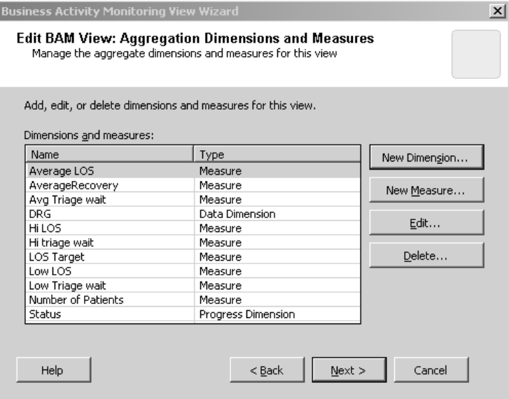
  MeasureName | BaseDataType | Display
  AverageRecovery | recoverytime | Average
  Avg Triage Wait | TriageWait | Average
  Hi LOS | actualLOS | Maximum
  Hi Triage Wait | TriageWait | Maximum
  LOS Target | Target | Average
  Low LOS | actualLOS | Minimum
  Low TriageWait | TriageWait | Minimum
  NumberofPatients | Patient Flow | Count

Click Next to move to the next screen of the wizard.

Once you have defined all of your measures and aggregation dimensions, a confirmation screen is displayed by the wizard, as shown in Figure 10.
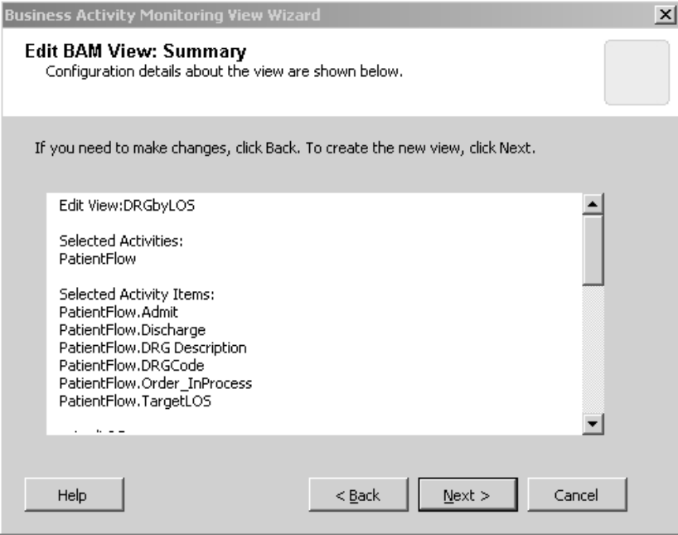
Figure 10 - Confirming the items and view you have created in the BAM View Wizard.

Click Next, and a familiar pivot table layout is provided.

Now you can drag and drop items onto the pivot table as you desire to build the initial report structure that will be displayed to the user. This can be modified at run time, but a default report layout should be created so we can complete one more configuration step.

Design Tip
You will notice that information is populated into the table as soon as you drop elements into it. This data is just mocked up for you to get a feel for what the report will look like once deployed. It is not actual data from your process.

Deployment Options

Before you deploy the BAM definition file to the server, you need to make a decision. Do you want to have the information available in real time or can you afford to wait a little bit and have the ability to slice and dice the information in more ways?

Technically speaking, a BAM definition holds the schema for the database objects that are created to store the context and business data that you want to track.
- Option #1 Real-Time Aggregation (RTA): If you choose to monitor in real time, the BAM infrastructure will create a set of relational tables in Microsoft SQL Server™. To enable RTA, click an area on the pivot table, and click the RTA button that is part of the pivot table toolbar. You will know that RTA is enabled when the button has a thin black outline around it.

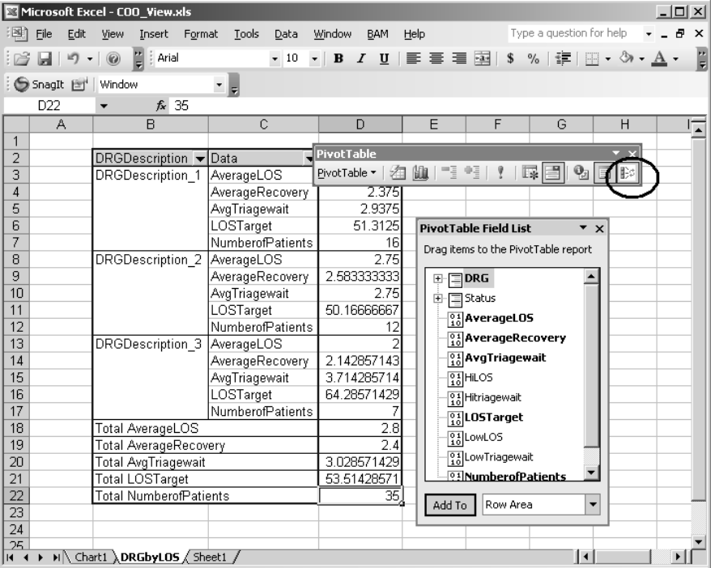
Figure 11 - Selecting a BAM view for real-time aggregation can be done by clicking the RTA button on the pivot table toolbar

Option #2 OLAP Cube: On the other hand, if you want more flexibility and power in the reporting options, you can have the BAM infrastructure create an OLAP cube to store the information as part of SQL Server Analysis Services. If you choose this option, you will need to process the cube before the pivot table will be populated in Excel. Since this is the default option, all you need to do is make sure that the RTA button on the pivot table toolbar is not selected. You will know that RTA is not enabled when the button has no thin black outline around it.

Usually, a knowledge worker can handle all of the previous steps without too much difficulty, and the completed Excel spreadsheet is given to the BizTalk team. It is at this stage that the actual data elements are mapped into the view and the BAM definition is deployed to the server. Let’s take a look at one of the ways we can tie this BAM definition to the BizTalk Server environment.

Once you have decided how you want to deploy your definition file (RTA or OLAP), you are ready to go.

Deploying the BAM Definition

While you were walking through the wizard and setting up the business metrics you wanted to monitor, a BAM definition file was being built. This file contains the information the BAM infrastructure needs in order to figure out what to track, and whether to deploy for RTA or OLAP.

Using the BAM Deployment Tool
From a command prompt, navigate to the directory <BizTalk Installation Dir>\Tracking. This directory holds a number of .config files and other objects that make up most of the BAM infrastructure. To deploy our BAM definition, you need to use the BAM deployment tool (bm.exe).

Design Tip
Bm.exe has a significant number of command-line options. To view a full listing, type bm.exe ? at the command prompt.

Using bm.exe, you can deploy, undeploy, and view a history of changes. To deploy your definition file, at the command prompt, type:
Bm.exe <path to your configuration file>\<configuration file name>

Design Tip
Bm.exe requires the .xls extension on configuration files in order to locate them successfully.

Assuming you have selected RTA for your BAM definition, after you execute bm.exe, you should see a screen similar to Figure 12 below.
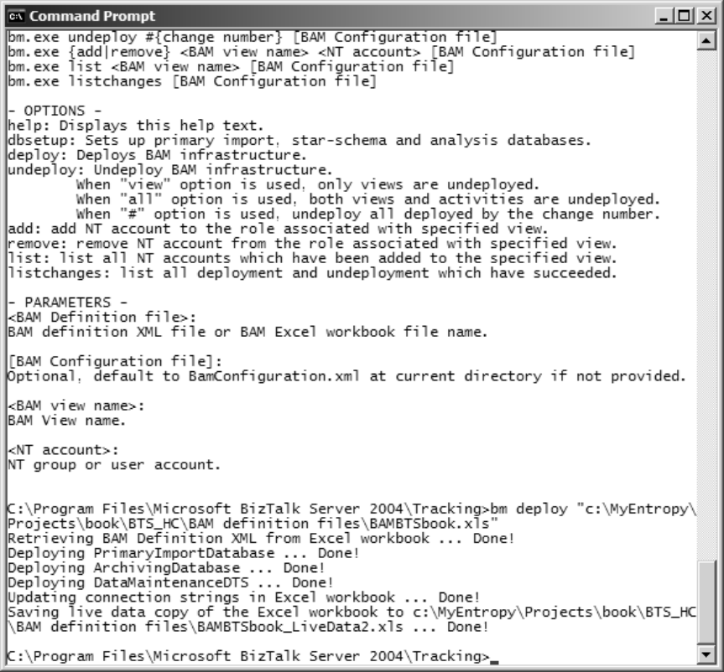
Figure 12 - Successful deployment of a BAM definition file for RTA

If you did not select RTA, the success message will have the following content:

Retrieving BAM Definition XML from Excel workbook ... Done!
Deploying PrimaryImportDatabase ... Done!
Deploying StarSchemaDatabase ... Done!
Deploying AnalysisDatabase ... Done!
Deploying ArchivingDatabase ... Done!
Deploying CubeUpdateDTS ... Done!
Deploying DataMaintenanceDTS ... Done!
Updating connection strings in Excel workbook ... Done!
Saving live data copy of the Excel workbook to c:\MyEntropy\Projects\book\BTS_HC
\BAM definition files\BAMBTSbook_LiveData1.xls ... Done!

Regardless of your deployment option, a new file called <BAM definition file name>_LiveData.xls is located in the same directory as your BAM definition file. If a file already exists with the same name, it will append a number to the end. This is the file that will eventually be used by the business.

Design Tip
The undeploy function of bm.exe can be very picky. If you don’t have the original BAM definition file or you forgot to save changes under a different file name, you cannot use the bm undeploy <BAM definition filename> option. Instead, first type:
Bm listchanges

This will give you a listing like this:
C:\Program Files\Microsoft BizTalk Server 2004\Tracking>bm listchanges
#1: Deploy ProNet_BAMViews.xls BamConfiguration.xml
By HAL2004\BTS at 2/12/2004 11:34:52 PM (v3.0.4902.0)
Activities: PatientTracking
Viewes: HeadNurseView
#2: Deploy ProNet_BAMViews.xls BamConfiguration.xml
By HAL2004\BTS at 2/13/2004 10:22:02 AM (v3.0.4902.0)
Activities: EncounterTracking
Viewes: AdminView

Note the number that precedes each deployment. Now, you can undeploy by the number associated with the view by typing:

Bm undeploy #<the number associated with the definition>

This is not the cleanest approach, but it works.

Populating the BAM View and Tracking BAM Activities

After deploying the BAM definition, the BAM infrastructure is ready to receive data. The way that data is received by the BAM infrastructure is through the event bus. The event bus can be accessed in one of two ways.
Integration Using the BAM SDK

One of the ways that the BAM infrastructure can interact with external systems is via an API that ships standard with the product. This approach allows fine-grained code-level control over how events are reported to the BAM event bus and also allows for events outside the scope of BizTalk to interact with the BAM infrastructure.

This technique can also be used to notify the BAM layer of events as they pass through a BizTalk pipeline component. This approach is relatively straightforward and is covered extensively in the product documentation. The focus of the remainder of this paper will be on integration at the orchestration layer, since this leverages a much more code-free approach to building linkages between BizTalk Server and Business Activity Monitoring.
Integration at the Orchestration Layer

If the activities you need to monitor have been implemented as part of either one or multiple orchestrations, BizTalk Server has a set of tools that allow you to build a code-free linkage to the BAM infrastructure. The next section details the steps necessary to process HL7 data through an orchestration to take advantage of BAM integration.

Designing Your HL7 Processing to Implement a BAM Solution

Using the BizTalk Accelerator for HL7, an HL7 solution can be implemented without taking advantage of BizTalk’s orchestration layer. However, to take advantage of BizTalk’s code-free linkage to the BAM infrastructure, you will need to process your data through an orchestration.

The following sections describe how to enhance an HL7 processing solution by adding an orchestration layer and tying the orchestration layer to your BAM views.

Building a Basic HL7 Processing Solution

Deploying the Necessary HL7 Schema

The BizTalk Accelerator for HL7 comes with 1300 predefined schemas to match every 2.X (2.1 through 2.4) message type. These schemas were generated from a Microsoft Access database provided by the HL7 organization, so they are considered “official” definitions. However, when it comes to a version 2.X message, you rarely see an “official” message. Rather, individual interpretations of messages abound. To accommodate this reality without adding a deafening amount of complexity to the schemas, the data fields, segments, and tables identifying looping structures are defined in a separate schema file per version to serve almost as a version-specific dictionary.

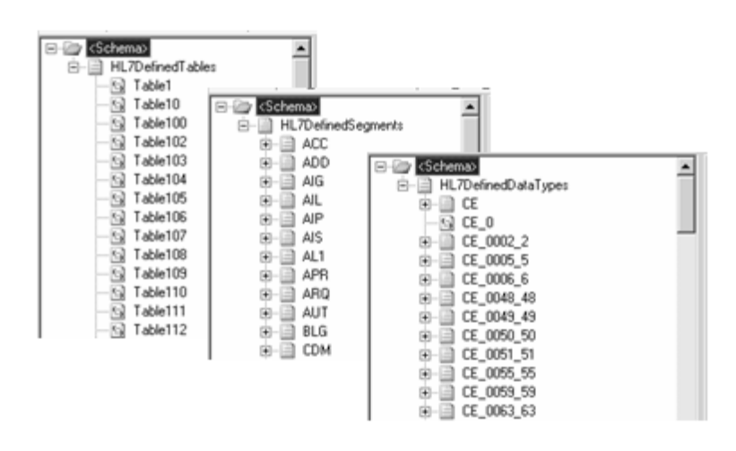
Figure 13 - Individual message components are defined in dictionary schemas

Then, individual message schemas were created for each message type. These individual message schemas depict the necessary message structure. Message schemas then reference the dictionary schemas for common individual definitions. You can think of this as the same way a Microsoft Visual Studio® project may reference external assemblies to access classes. In fact, a BizTalk project, just like any other development project in Visual Studio, follows the same reference rules of any object-oriented development.

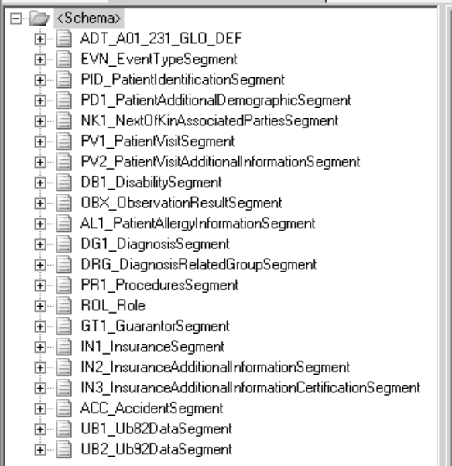
Figure 14 - Message schemas depict the message structure and reference the dictionary schemas for individual definitions

The benefit of this definitional separation is that message structures can be both globally and locally altered from the official standard. If the user wishes to alter the definition of a segment or data field for every message that the user processes, the alteration would take place in the definitional schema. If the user wishes to only vary from the standard for that particular message type, the change can be made locally in the message schema. The usability benefit of this definitional separation is that the message schemas appear to be less complex, and thus easier to work with inside of the mapping tool.

Because of the backward-compatibility rules, the version 2.4 MSH Segment and acknowledgment (ACK) structures are appropriate for all prior versions. Further, regardless of the specific HL7 version you are processing, you will always have an MSH Segment and the engine will auto-generate acknowledgments. For this reason, separate schemas have been provided for the MSH Segment and for HL7 acknowledgments in a version 2.4 format.

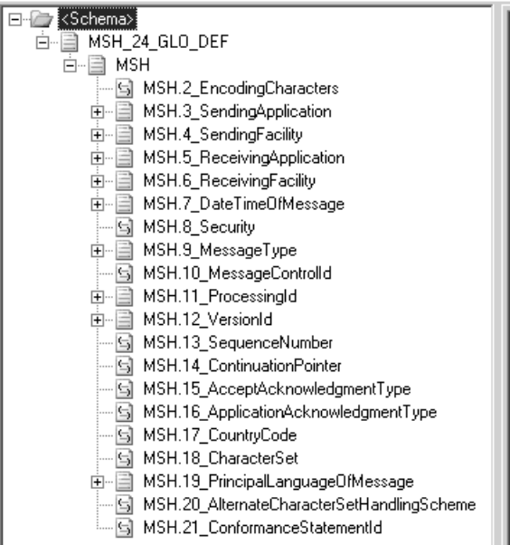
Figure 15 - The Message Header Schema

To understand what needs to be deployed, let’s take a look at the provided schemas. Starting with the premise, as discussed earlier, that both definitional and message structure schemas are provided by version, we know that we will need to deploy both of these schema types. Because the message structure schemas rely on the definitional schemas, we need to make sure that the message structure schemas have the appropriate reference to the definitional schemas once deployed. Additionally, we will need to deploy the schemas that define the MSH Segment and acknowledgments (ACK).

Design Tip
The necessary schema deployment steps are defined below. Refer to the End-to-End Tutorial found in BizTalk Accelerator for HL7 Help documentation for a detailed guide to this process.

Deploying the Project Containing MSH and ACK Schemas

The MSH Segment is used to identify the correct message body schema to use to validate the message. This schema must be deployed initially upon accelerator installation as it will be used for all of your v2.x processing. Also, the ACK schema is used to generate appropriate message acknowledgments. To deploy them, add a New Project to your solution. Into the project Add a New Item. The MSH schema is contained in a project in the HL7 Projects category called BTAHL7V2XCommon Project.

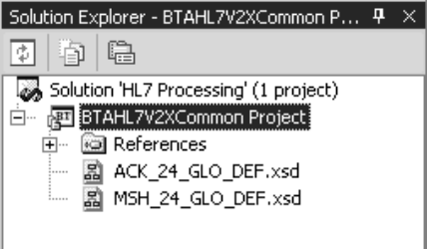
Figure 16 - BTAHL7V2XCommon Project contains schemas for the MSH Segment and HL7 Acknowledgments

After creating and setting a required Assembly Key (.snk) file, deploy this project. This is a one-time step that is necessary for all of your HL7 processing because now the message header and acknowledgment schemas are available in the configuration database.

Deploying the Version-Specific Definitional Schemas

Definitional schemas are provided for each of the 2.X versions in predefined BizTalk projects by version. You will need to deploy the appropriate project for the HL7 version you are processing. In Solution Explorer, add an existing HL7 project. The projects are located under HL7 schema projects and are identified as BTAHL7V231Common Project, where the “V231” indicates the version number. When this opens in Solution Explorer, notice that three schemas — datatypes_231.xsd, segments_231.xsd, and tablevalues_231.xsd — are included in the project.

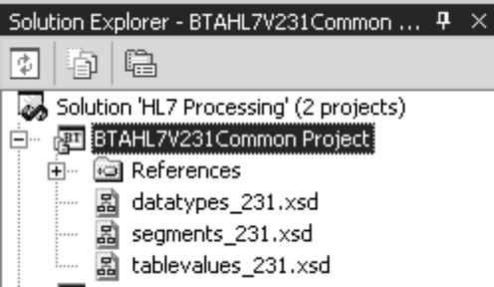
Figure 17 - BTAHL7V231Common Project contains the definitional schema referred to by all version 2.31 message schemas

After applying the necessary Assembly Key (.snk) file, deploy this project. This is a one-time step that is necessary for all of your version 2.31 processing because now the definitional schemas referenced by all version 2.31 schemas are available in the configuration database.

Deploying Specific Message Schemas

Once the header, acknowledgment, and version-specific definitional schemas are deployed, you will configure and deploy message-specific schemas as necessary for your HL7 processing. In Solution Explorer, add an empty HL7 project. In this project, you will add a reference to the previously deployed project containing the definitional schemas for the message version you are processing. For instance, if you are processing a version 2.31 ADT message, you would reference the Version2.31CommonProject you just deployed.
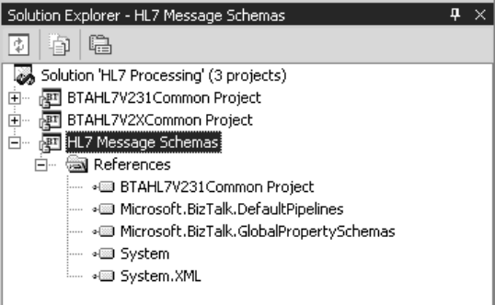
Figure 18 - Reference the version-specific definitional schema in your HL7 message project

Once the reference is added, you will add a message schema to this project for each message type you are processing. To do this, add a new item to the project, selecting schemas under BTAHL7 Items. In the schema selection dialog box, select the version and message type you are interested in. For example, if you are processing a version 2.31 ADT^A01 message, select 2.31 for Version, ADT for Message Type, and A01 for Trigger Event, as shown in Figure 19. This will add the message definition schema to your project.

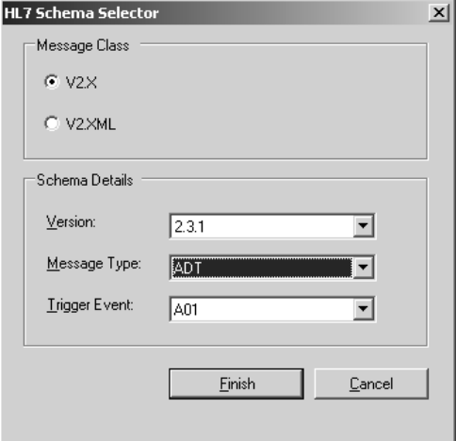
Figure 19 -Select the version, message type, and trigger event code to add a message definition schema

Once you have added all of the message schemas you are interested in, apply the necessary Assembly Key (.snk) file and deploy this project. Once done, these are the schemas you will reference and use in your maps and orchestrations.

Design Tip
For ease of maintenance, it is a recommended practice to deploy your message schemas separately from maps and orchestrations.

Configuring Acknowledgments

The HL7 Receive Pipeline automatically generates HL7 Acknowledgments. However, if you do not configure BizTalk appropriately, the acknowledgments will sit unprocessed in the message box.

The accelerator makes use of Party definitions to associate acknowledgments to sending applications. A Party is the means through which BizTalk uniquely identifies a sending application by associating the sending application’s identifier with the specific acknowledgment and batching configurations desired for that application. Once a Party has been defined, the BTAHL7 Configuration Explorer is used to configure the type and format of the acknowledgments sent to that Party. You need to add a Party for each application that sends data into BizTalk. The Party definition must contain the value that the particular application places in the MSH.3 field in the message header, as that is how the parser matches the data to the Party definitions.

Parties are defined and configured in BizTalk Explorer. To add a Party, simply right-click the Parties tab within BizTalk Explorer, under your configuration database, and select Add New Party. Name the Party for the value found in the MSH.3 of your incoming message. On the Ports tab, select the send port that is subscribing to the acknowledgment going to this application.

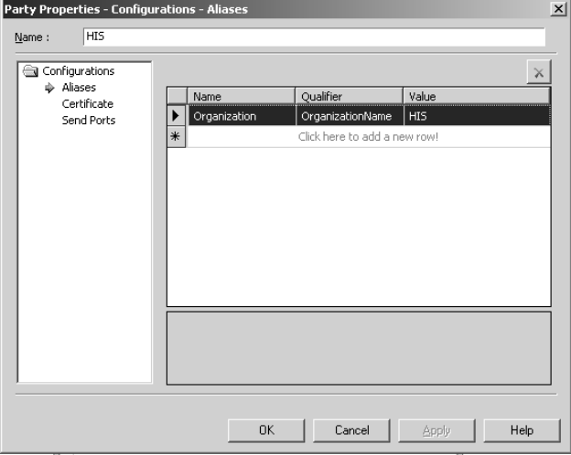
Figure 20 - Define a Party for each application sending data into BizTalk

Once the Party has been defined, you can configure the acknowledgments going to this Party in the BTAHL7 Configuration Explorer, accessed via the Start menu.
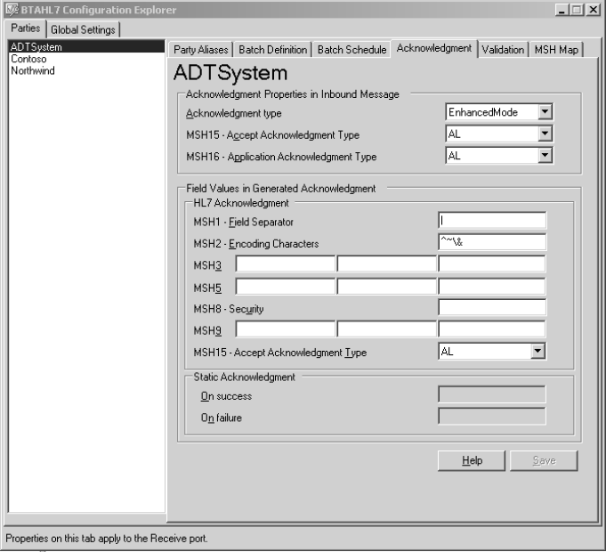
Figure 21 - BTAHL7 Configuration Explorer

By selecting the Acknowledgment tab, you can define the level of acknowledgment you want to generate along with any changes you would like made to the MSH Segment in the acknowledgment.

HL7 Receive Pipeline

The BTAHL7 (BizTalk Accelerator for HL7) Receive Pipeline contains its own disassembler component (DASM) that reads the MSH Segment to determine the message type and version. Based on this information, it then looks to the configuration database to locate the appropriate message schema that defines the message.

Armed with the schema that defines the structure, the data is then parsed, or disassembled, from its delimited structure and converted into XML for use by the BizTalk engine. As the data is disassembled, it is validated against the message schema. This all occurs within the disassembler component of the pipeline and is alternatively referred to as the BTAHL7 Disassembler. Unlike the default flat-file DASM provided by BizTalk Server, the HL7 one does not require that a schema be specified per pipeline.

Once the message is validated, the DASM also creates the appropriate acknowledgment(s) of the message. More than one acknowledgment may be created, depending on the acknowledgment level that was configured for the Party sending the original message. As discussed later, the DASM will create system and application-level message acknowledgments. These are created post validation by the BTAHL7 DASM component and both the XML-ized message and acknowledgment are then published to the BizTalk message box, where they will remain until picked up by subscribing systems.

The BTAHL7 Receive Pipeline is automatically deployed when you install the BizTalk Accelerator for HL7. Thus, there is out-of-the-box functionality, meaning that you need do nothing special to use the pipeline in your HL7 receive locations.
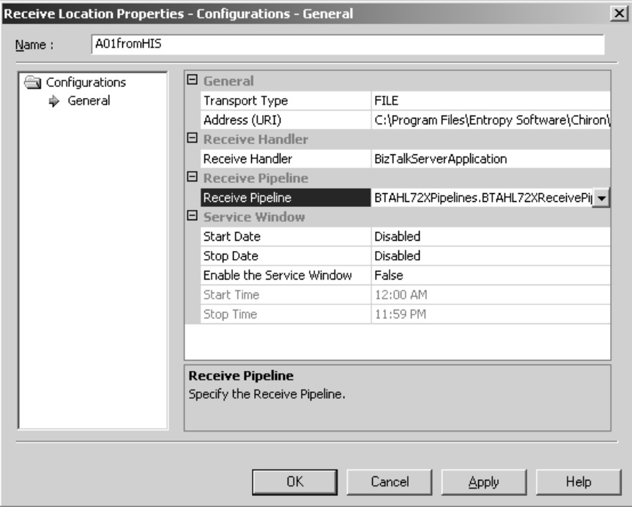
Figure 22 - Locations receiving HL7 data must use the BTAHL7 Receive Pipeline

However, functionally speaking, the BTAHL7 Receive Pipeline is simply a custom BizTalk pipeline. Because of this, you can re-use the DASM within your own custom pipelines and have the ability to add additional components before or after the DASM stage. This is useful if you need to preprocess the data before publication to the message box.

HL7 Send Pipeline

Similar to the BTAHL7 Receive Pipeline, the BTAHL7 Send Pipeline uses the HL7 message schema to assemble, or serialize, and validate the structure of the data into a delimited flat file before it is sent to subscribing systems. Essentially, the BTAHL7 Assembler (ASM) takes the XML document from the BizTalk message box and returns an HL7 encoded message.

As with the BTAHL7 Receive Pipeline, the BTAHL7 Send Pipeline is automatically deployed upon installation of the BizTalk Accelerator for HL7. The BTAHL7 Send Pipeline will be used in all send port definitions that are subscribing to HL7 data and require HL7 output.
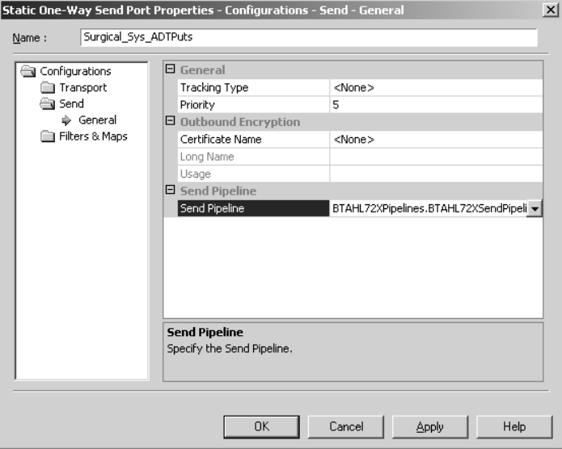
Figure 23 - Send ports sending HL7 data must use the BTAHL7 Send Pipeline

As with the BTAHL7 Receive Pipeline, the BTAHL7 ASM can be re-used in your own custom send pipelines. A component added before the assembly stage will affect the data while it is still in its XML form, where a component added afterwards will occur once the data has already been serialized into an HL7 encoded message.

Mapping HL7 Data

Although you need the BizTalk Accelerator for HL7 to process HL7 data correctly, it is important to remember that you have access to all the basic components of BizTalk Server as well. That means that you can send the data through maps or orchestrations as needed. Given the varied data structures of line-of-business applications, the odds are that you will need to transform your HL7 data into a new shape or that you will need to create HL7 data from an old shape. You will use BizTalk maps to accomplish these needs.

The BizTalk mapping tool allows for only a single input and output to a map. This translates to a single schema on the input and a single schema on the output. The schema you use for HL7 data is the message schema you deployed earlier. That message schema defines the segment structure for only the body of the message. (Remember, the MSH Segment has its own schema.) Thus, when mapping HL7 data, you only have access to the body of the message. When mapping from HL7 data, this generally is not an issue because the body of the message contains everything in the message header segment except the sending and receiving system identifiers. However, when mapping to HL7, you will need to take some extra steps to assign an MSH Segment to the beginning of the message body that your map creates.

When mapping from HL7 data to a new format you will use the HL7 message schema that matches your input data as the Data Source Schema. You then use a schema that defines your desired output as your Destination Schema. Once both are defined, you can drag and drop HL7 field components to the appropriate output element, using Functoids to alter the data as necessary.

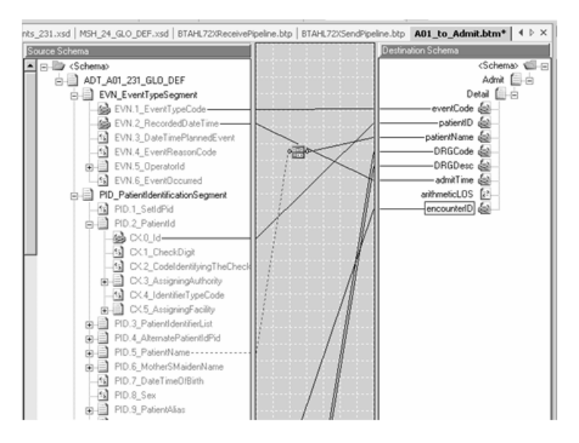
Figure 24 - A map with HL7 data as input creating non-HL7 data

Once you are satisfied with your map output, you are ready to deploy the map project. To do this, first add an assembly key file to the project, and then select build and deploy. Once deployed, the map can be called via a Receive Port, as part of an orchestration Transform shape, or via a send port.

Design Tip
Because BizTalk relies on XML data for map processing, all maps called via a send port occur on the data before the ASM serializing. This is helpful to keep in mind when coordinating map outputs.

Configuring an Orchestration to Accept an HL7 Message

As discussed earlier, the BTAHL7 Receive Pipeline contains its own disassembler component (DASM) that reads the MSH Segment to determine the message type and version. Based on this information, it then looks to the configuration database to locate the appropriate message schema that defines the message. As a part of the parsing process, the DASM splits the HL7 message into three parts: the message header (MSH Segment), the message body (all standard-defined segments after the MSH Segment), and Z-segments.
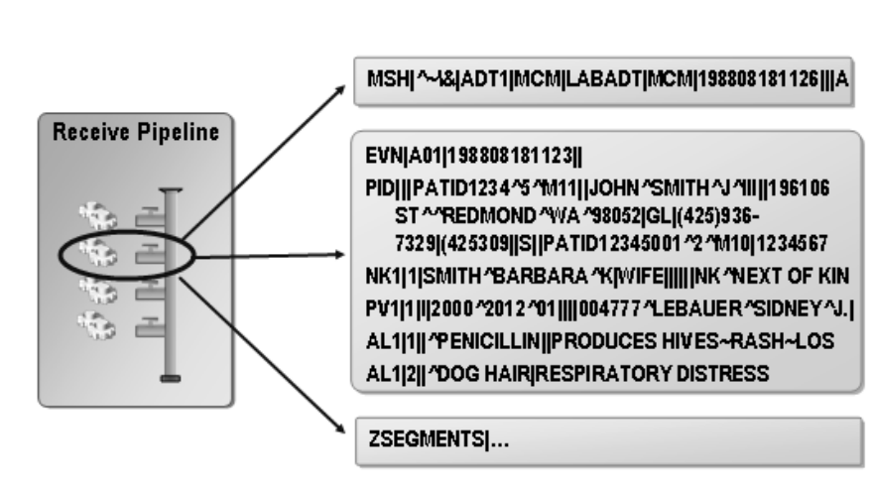
Figure 25 - The HL7 Receive Pipeline parses the message into three parts

In order to determine which schema to use to validate the message, the DASM component uses the MSH Segment to determine the message type (MSH.9) and version (MSH.12). The HL7 schemas are named according to message type and version as well, ADT_A01_23_GLO_DEF.xsd, for example. In the schema name, “ADT_A01” identifies the message type, matching the MSH.9, and “23” identifies version 2.3, matching the MSH.12.
Figure 26 - The BTAHL7 DASM uses the MSH Segment to determine which schema to use to parse the data

The HL7 message and definitional schemas define all other segments beyond the MSH Segment. The MSH is split from the body of the message for consistency, so that the parser can use it to identify the exact message schema to use, such as the ADT_A01_231_GLO_DEF.xsd in this case. Beyond that, Z-segments are split off so that they can be defined as needed.

When sending HL7 data through an orchestration the orchestration will actually receive a 3-part message. That means that a multi-part message type must be defined in order for the data to be handled correctly. When creating the multi-part message type, you must create the included parts in an exact order, using the case-specific names of: MSHSegment (created first), BodySegments (created second), and ZSegment (created last). When finished, it will look like Figure 27.

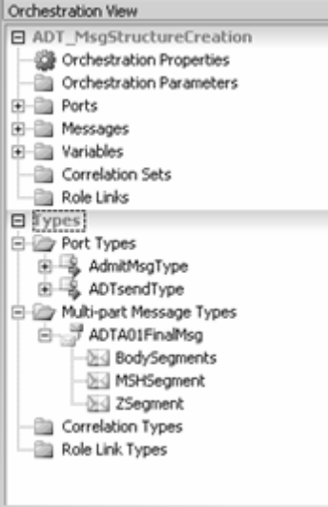
Figure 27 - To receive data into an orchestration, define a multi-part message type composed of MSHSegment, BodySegments, and ZSegment parts

As you create each part of the multi-part message type, you will need to associate each type with a schema or definition. The steps for defining a multi-part message for an HL7 message are detailed further in the Message Enrichment Tutorial provided with BizTalk Accelerator for HL7.

Basically, the BodySegments type is defined by the HL7 schema for the message you are processing, such as the ADT_A01_231_GLO_DEF.xsd for example. For the other two types, you will select a .NET class. Following are the steps for configuring them:

- After adding a type and naming it MSHSegment, move to the Properties window under Type, select .NET Classes, and then click <Select from referenced assemblies>. In the Select Artifact Type dialog box, in the left pane, click System.Xml. In the right pane, click XmlDocument, and then click OK.

- After adding a type and naming it ZSegment, move to the Properties window under Type, select .NET Classes, and then click System.String from the drop-down list.

Once all three types under the Multi-Part Message Type for your HL7 message are defined, create a Message definition and configure it as a Multi-Part Message Type, selecting your newly defined definition. You will then configure the orchestration Receive shape with this message definition.
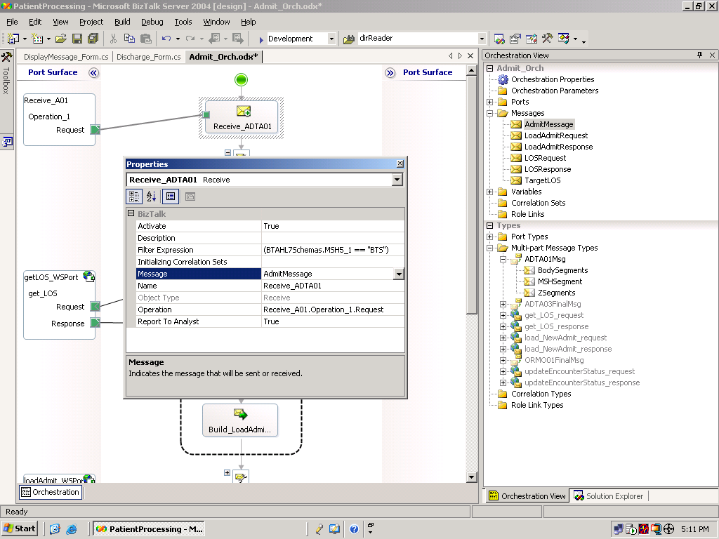
Figure 28 - Configure the Receive shape in the orchestration to use the multi-part message definition

Once you have configured the orchestration to receive the HL7 message, you can then design whatever process flow is necessary to accomplish your business process tasks.

The following example shows an ADT^A01 message flowing into an orchestration. From there, a Web service is called to determine the exact length of stay (LOS) associated with whatever DRG code is included in the message. This LOS is then accessed by the BAM interface layer for reporting on the expected compared to actual LOS for this patient. Finally, the message is passed through a send port for processing by the receiving application.

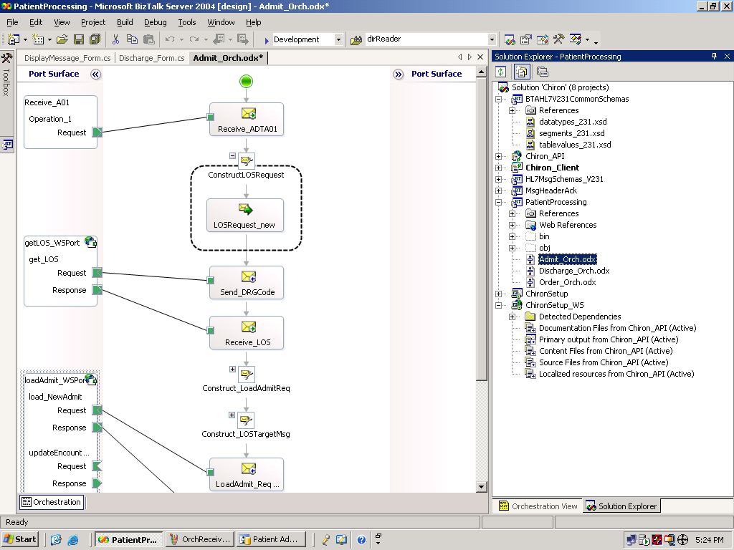
Figure 29 - Orchestration depicting an ADT^A01 message initiating an orchestration that calls a Web service, updates the BAM store, and sends the message to the receiving application

As mentioned earlier, if the activities you need to monitor have been implemented as part of either one or multiple orchestrations, BizTalk Server has a set of tools that allow you build a code-free linkage to the BAM infrastructure. You have just accomplished the first step in this process by designing and configuring an orchestration. The next step will be to integrate the orchestration with the Tracking Profile Editor, in which you define which elements in the data flow will be monitored to populate the BAM view you created previously.

Sample Orchestrations

You could use the following three orchestrations to follow a single patient’s encounter through the facility:

- Admit_Orch.odx
- Discharge_Orch.odx
- Order_Orch.odx

The patient is admitted through a Patient Processing system that maintains a database of patients by encounter ID. As a patient moves through the facility, the three orchestrations will continue to update the Patient Processing system’s database as to the patient’s status separately from the HL7 messages being exchanged.

The Admit_Orch orchestration:

- Receives an v2.31 ADT^A01.
- Uses a Web service to call a database containing LOS codes by DRG. This Web service populates an LOS value into the ADT^A01 based on the patient’s DRG code. This LOS value will be tracked by the BAM layer to report how the patient’s actual LOS differs from the target LOS as determined by the patient’s DRG code.
- Once the LOS is populated into the message body, a message assignment is used to assign the MSH Segment to the ADT^A01 message body.
- Sends the message to a directory called HISTargetApplications where it presumably will be picked up by an interested system that processes messages sent from the HIS system.

Once an order is placed for the patient, the Patient Processing system’s database will need to be updated that an order has been placed. To do this, the Order_Orch orchestration:

- Receives an v2.31 ORM^O01.
- Uses a Web service to update the patient’s status by encounter ID in the Patient Processing system’s database.
- Uses a message assignment to assign the MSH Segment to the ORM^O01 message body.
- Sends the message to the HISTarget directory.

Once the patient is discharged, the Patient Processing system’s database will be updated that the patient associated with a certain encounter ID has been discharged. To accomplish this, the Discharge_Orch orchestration:

- Receives a v2.31 ADT^A03.
- Uses a Web service to update the patient’s status by encounter ID in the Patient Processing system’s database.
- Uses a message assignment to assign the MSH Segment to the ADT^A03 message body.
- Sends the message to the HISTarget directory.

The Web service call that populates the LOS in the Admit_Orch orchestration is not necessary to process HL7 data, but rather it allows access to a remote database containing the LOS values by DRG as determined by the current Medicare guidelines. This database was created from values supplied by the CMS for use in this solution. This architecture allows for easy updating of LOS values by simply updating the remote database. In this manner, the integration infrastructure will not need to be altered.

The Web service updates are in place in order to demonstrate the patient’s progress through the facility separately from the message flow, as the Patient Processing system indicates the patient’s changed status.

It should be noted that to configure BAM for HL7 processing does not require these orchestrations either. The LOS values added in through the Web service calls provide access to values necessary for the KPIs that this solution is tracking.

Whether you use these orchestrations or create your own, you will use the Tracking Profile Editor to link the data flowing through the orchestration to the BAM view you configured earlier.

Integration with BizTalk Server 2004 Using the Tracking Profile Editor

The Tracking Profile Editor (TPE) is a graphical design tool that allows you to tie business data and context data from an orchestration to specific business activities defined as part of a deployed BAM definition.

By using the TPE, you can rapidly map data from promoted properties, distinguished fields, and context data, such as the start and/or end time of an event.

Before using the TPE, make sure that you have deployed your BAM definition and any orchestrations that you need to work with. Once complete, open the TPE from the BizTalk Server 2004 program group.

The sole purpose of the TPE is to create a tracking profile. The tracking profile binds the orchestration data to the BAM activities you defined in the BAM configuration file.

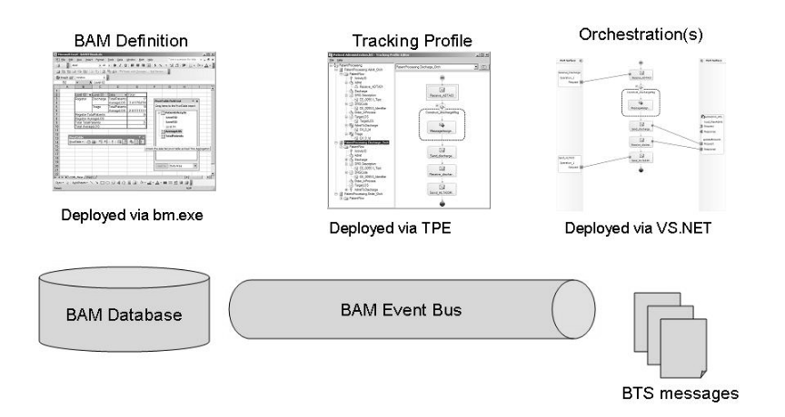
Figure 30 - The tracking profile binds together the BAM definition with one or more orchestrations

Creating a New Tracking Profile

To create a new tracking profile, open the TPE and click New on the File menu. Select the assembly that contains the orchestration(s) that you would like to tie to the BAM definition.

The assembly that contains the three orchestrations discussed above is called PatientProcessing, so you will select that assembly for the TPE to import.

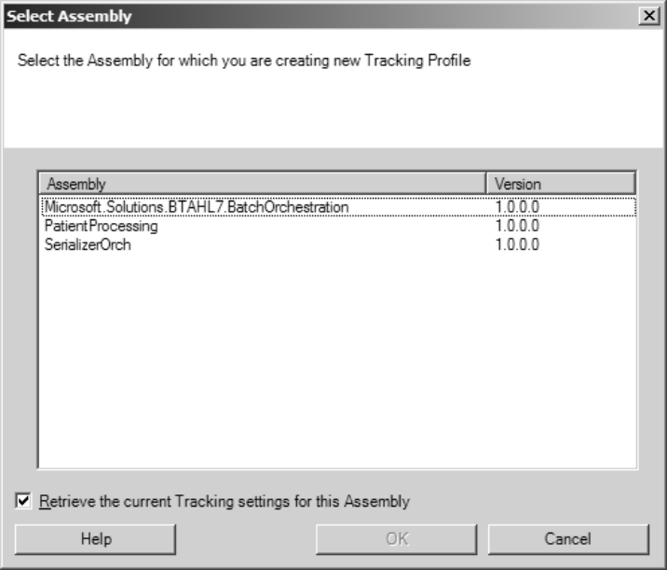
Figure 31 - Select the orchestration assembly for the TPE to import. If your orchestration assembly does not appear, make sure it has been deployed.

Once you click OK, all of the orchestrations contained within the assembly are shown in the right-hand pane.

Design Tip
If you want to correlate multiple orchestrations in a BAM view and wish to use the TPE, make sure that all of the orchestrations are in the same assembly. Otherwise, you’ll have to use the SDK.

To tie your orchestration to a BAM definition, right-click one of the orchestrations and select Import Activity Definition, as shown in Figure 32.

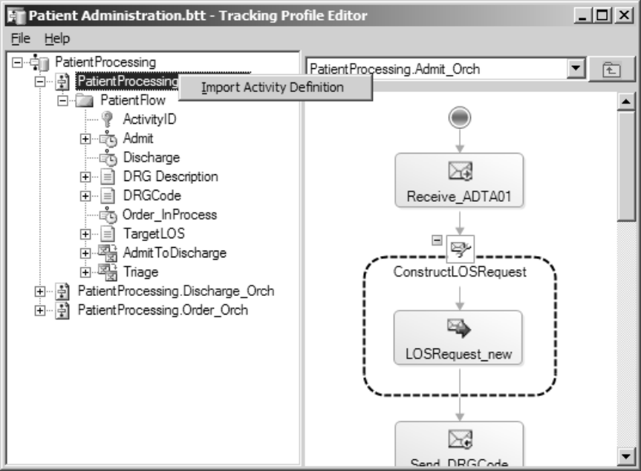
Figure 32 - Importing a BAM activity definition into the TPE

The activity definition is not the Excel spreadsheet itself, but an XML document that gets created in the deployment process.

Navigate to the directory where you stored your BAM definition spreadsheet, and you should see an XML file in the same directory. Select this file and click OK.

You will see a list of all of the BAM activities appear under each orchestration. To map data fields to the BAM activity, right-click a message shape in the orchestration pane and select Messages/Parts, as shown in Figure 33.
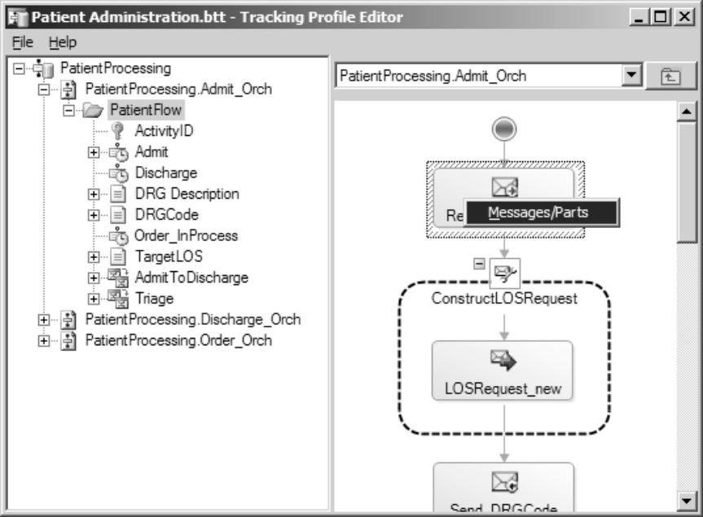
Figure 33 - Select the message you wish to inspect

Once selected, you will be taken to a screen that will allow you to drill down into a message and view the schema associated with that step in the orchestration.

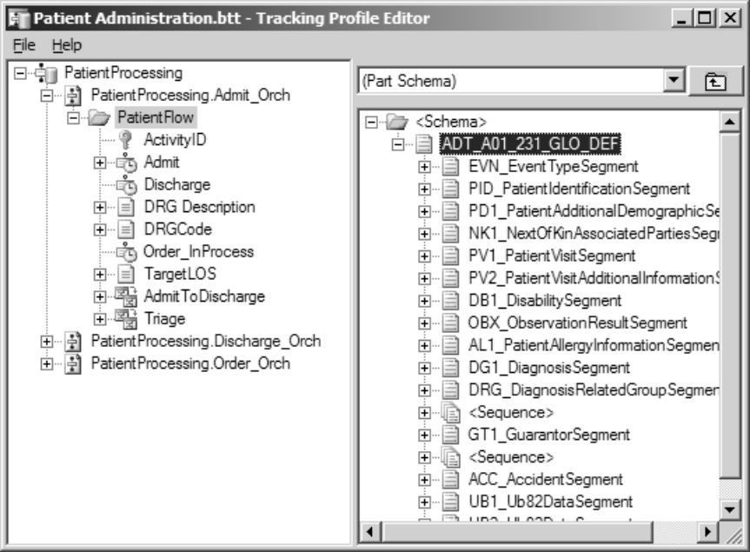
Figure 34 - Drill down into a message part for a selected step in the orchestration

To map an element in this message to a business activity, simply drag and drop the data element from the left-hand pane to the business activity on the right.

Design Tip
When working with HL7 data, the MSH Segment will not be available in the TPE. Map these fields to a ZSegment if needed in a BAM view.

You will notice that business activities that were configured as milestones appear in the list with a clock icon next to them. To populate these activities, select the orchestration step that is related to the activity, right-click the activity, and select Associate with end of selected action.

Keep in mind that if you have multiple orchestrations being aggregated in a view, you will only populate milestone information for activities that occur within a particular orchestration.

For example, you would not populate the Patient Discharged milestone while working with the Admit orchestration in the TPE because there is no orchestration activity associated with that milestone in the Admit orchestration. Instead, populate the milestone under the child elements listed under the Discharge orchestration.

Aggregating Events with Continuation Tokens

The TPE also allows you to build relationships between orchestrations for the purpose of BAM reporting through the use of continuation tokens. A continuation token is a key that tells the BAM infrastructure that two disparate orchestrations are part of the same overall end-to-end process. In the TPE, you define the unique identifiers of the token (usually part of the message payload) that are made up as a composite or single field in the message itself. For example, if we have an admit process that is separate from a discharge process, we can link the two together under a continuation token defined by patient ID and encounter ID.

Keep in mind that these orchestrations can operate completely independently of each other during run time. Creating a continuation token only binds orchestrations together at the BAM layer, and this will not affect how messages are processed by the system.

To create a continuation token between two orchestrations, select the orchestration that happens first in the series. Right-click the orchestration in the left-hand pane and select New Continuation, as shown in Figure 35.

Once you select this, a new icon will appear in the tree structure as a child to the orchestration. Map to the continuation icon the data elements that uniquely identify this process to the system. For example, you might drag and drop a claim number and subscriber SSN to this field if it uniquely identifies the process.
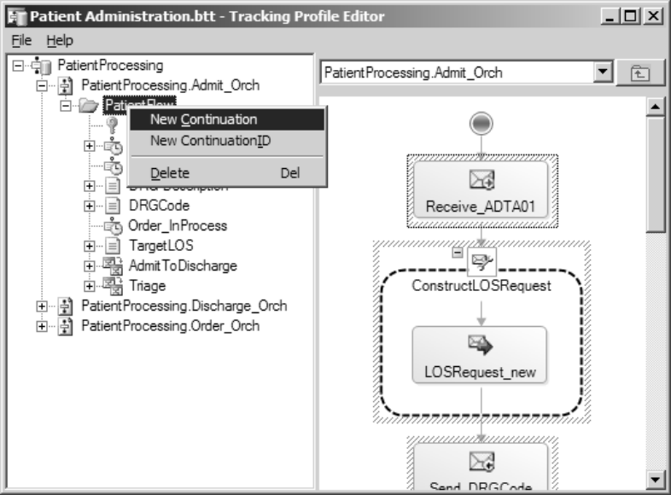
Figure 35 - Create a new continuation in the orchestration that happens first. In this case, the Admit_Orch orchestration will happen before the Discharge_Orch orchestration takes place, so the continuation is initiated in Admit_Orch orchestration

Next, select the orchestration that will occur afterwards. Right-click in the left-hand pane and select New Continuation ID, as shown in Figure 36.

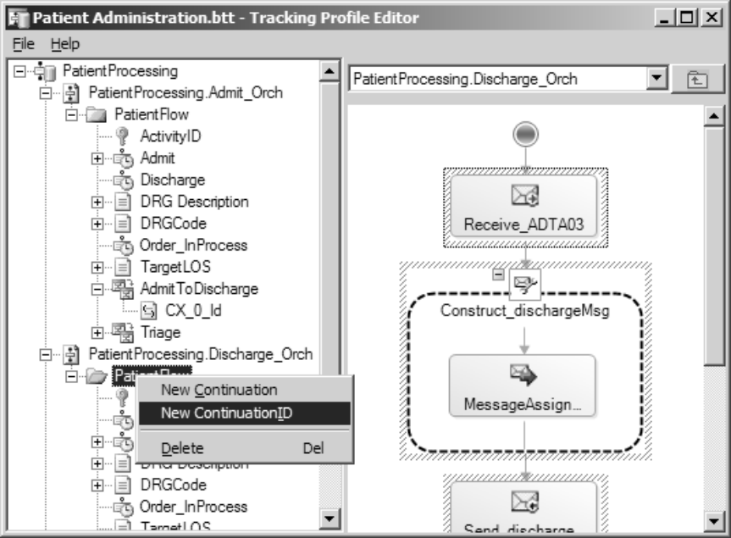
Figure 36 - Creating a new continuation ID in an orchestration that follows the initiating orchestration

You will see a key icon appear in the tree structure below the orchestration. Map data fields from the messages available in this orchestration that correspond to the ones you selected in the continuation initiator. These elements can appear in totally different message structures; only the values of the elements matter.

Once this is complete, any messages that have a match between data that appears in a continuation initiator and any subsequent continuation followers will be correlated together at the BAM layer. This will allow you to calculate, for example, end-to-end processing time for a business process that spans multiple orchestrations.

Deploying the Tracking Profile

Once all data, context information, and continuations have been mapped, you are ready to deploy the tracking profile. To do this, select Deploy from the File menu in the TPE. You should see a confirmation message box appear upon success.

Viewing BAM Activities

To view the reporting on the activities you have defined, open the spreadsheet created by the bm.exe tool called <BAM definition file name>_LiveData.xls.

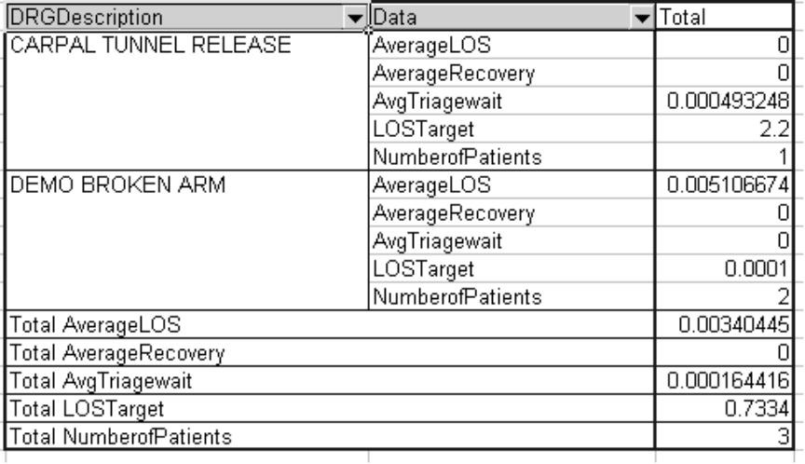
Figure 37 - An example BAM pivot table being populated using real-time aggregation (RTA)

Design Tip
If you have not run any data through the system and attempt to open the LiveData spreadsheet, you will get an error that the pivot table could not be refreshed. To resolve this, simply run some data through the orchestrations and the error message will disappear.

Your pivot table information will initially load with the most current data. However, if you leave the window open, you can refresh the data by clicking on the red exclamation point in the pivot table toolbar, shown in Figure 38.

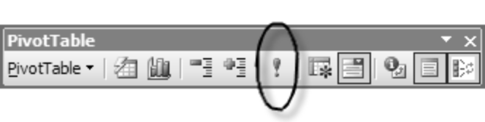
Figure 38 - To update the information in the pivot table, click the refresh button in the Pivot Table toolbar

Charts and Graphs

A powerful way to display this information is in the form of a chart or graph. Since BAM’s user experience is based on Excel pivot tables, you can easily build charts and graphs using the native Excel functionality in these areas. Figure 39 shows a simple chart of a hospital’s workload by DRG and average wait times by DRG.

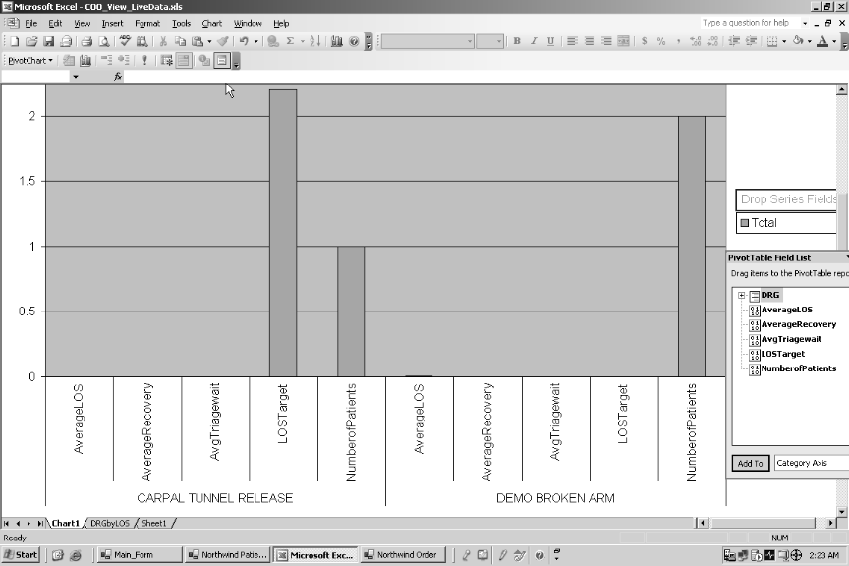
Figure 39 - An example of charts built on data coming from the BAM infrastructure

Beyond Excel, these charts and graphs can be displayed in a portal or intranet site utilizing Microsoft Windows® SharePoint® Services. Together, BAM information can be viewed and accessed in a very interactive manner.

Summary

Easily implemented business activity monitoring has become a reality with the introduction of BizTalk Server 2004. By leveraging Excel, business users have a familiar user experience where they can both define what kind of metrics they want to track, and later view the data and build their own charts and reports from that data.

By designing business activity monitoring into your HL7 processing, you can take advantage of the data that is flowing daily through your organization to address the higher-level concerns faced by your organization’s executives. After identifying the issues of concern to your executives, such as reimbursement rates and staffing issues, you then take a look at your HL7 messages to determine which data fields can be used to quantify the organization’s performance in those areas. Armed with that information, you can configure BizTalk’s BAM infrastructure to monitor those particular HL7 message fields and report on them in a user-friendly interface.

All in all, Microsoft has built a solid, easy-to-implement business activity monitoring solution that can be rapidly implemented. Through designing business activity monitoring into your HL7 processing, you gain the advantage of two superior business processing solutions through a single implementation. Adding a BAM layer to your integration strategy not only validates your IT investment, it improves the efficiency of the organization as a whole when the data monitored through your BAM solution serves to objectify your organization’s process-improvement initiatives.

What’s Keeping Our Nation’s Healthcare Executives Up at Night?, Gartner and CGEY, April 2002

